**Request Dispature**

Simple servlet

import java.io.IOException;  
import java.io.PrintWriter;  
  
import javax.servlet.*;  
import javax.servlet.http.*;  
  
  
public class Simple extends HttpServlet {  
  
 public void doGet(HttpServletRequest request, HttpServletResponse response)  
 throws ServletException, IOException {  
  
 response.setContentType("text/html");  
 PrintWriter out = response.getWriter();  
   
 String p=request.getParameter("userPass");  
 if(p.equals("servlet")){  
 RequestDispatcher rd=request.getRequestDispatcher("welcome");  
 rd.forward(request, response);  
   
 }  
 else{  
 out.print("Sorry username or password error!");  
 RequestDispatcher rd=request.getRequestDispatcher("login.html");  
 rd.include(request, response);  
 }  
   
 }  
  
}

**welcome servlet**

import java.io.IOException;  
import java.io.PrintWriter;  
  
import javax.servlet.ServletException;  
import javax.servlet.http.HttpServlet;  
import javax.servlet.http.HttpServletRequest;  
import javax.servlet.http.HttpServletResponse;  
  
  
public class WelcomeServlet extends HttpServlet {  
  
 public void doGet(HttpServletRequest request, HttpServletResponse response)  
 throws ServletException, IOException {  
  
 response.setContentType("text/html");  
 PrintWriter out = response.getWriter();  
   
 String n=request.getParameter("userName");  
 out.print("Welcome "+n);  
 }  
}

**login.html:**

<form action="go" method="get">

Name:<input type="text" name="userName"/><br/>

Password:<input type="password" name="userPass"/><br/>

<input type="submit" value="login"/>

</form>

**Next example:**

**Form code**

**.java**

import jakarta.servlet.*;

import jakarta.servlet.http.*;

import java.io.IOException;

import java.io.PrintWriter;

public class http_post extends HttpServlet{

public void doPost(HttpServletRequest req, HttpServletResponse res)

throws ServletException, IOException {

res.setContentType("text/html");

PrintWriter out=res.getWriter();

String n=req.getParameter("user_name");

String e=req.getParameter("email");

String c=req.getParameter("user_course");

String co=req.getParameter("condition");

if(co!=null){

if(co.equals("checked")){

out.println("NAME = "+n);

out.println(" ,,, EMAIL = "+e);

out.println(" ,,, COURSE = "+c);

out.println(" ,,, "+co); }

else{

out.println("you do not accept condition"); }

}

else{

out.println("you do not accept condition"); }

}

}

**.html**

<html>

<body>

<form action="http_post" method="post">

<table>

<tr>

<td>NAME</td>

<td><input type="text" name="user_name"></td>

</tr>

<tr>

<td>EMAIL</td>

<td><input type="email" name="email"></td>

</tr>

<tr>

<td>COURSE</td>

<td>

<select name="user_course">

<option value="C">C</option>

<option value="SQL">SQL</option>

<option value="C++">C++</option>

</select>

</td>

</tr>

<tr>

<td>

<input type="checkbox" value="checked" name="condition">

</td>

<td>

Conditions

</td>

</tr>

<tr>

<td>

<button type="submit">SUBMIT</button>

</td>

</tr>

</table>

</form>

</body>

</html>

**.xml**

<?xml version="1.0" encoding="UTF-8"?>

<web-app version="6.0" xmlns="https://jakarta.ee/xml/ns/jakartaee" xmlns:xsi="http://www.w3.org/2001/XMLSchema-instance" xsi:schemaLocation="https://jakarta.ee/xml/ns/jakartaee https://jakarta.ee/xml/ns/jakartaee/web-app_6_0.xsd">

<servlet>

<servlet-name>t5</servlet-name>

<servlet-class>t5</servlet-class>

</servlet>

<servlet>

<servlet-name>http_post</servlet-name>

<servlet-class>http_post</servlet-class>

</servlet>

<servlet-mapping>

<servlet-name>t5</servlet-name>

<url-pattern>/t5</url-pattern>

</servlet-mapping>

<servlet-mapping>

<servlet-name>http_post</servlet-name>

<url-pattern>/http_post</url-pattern>

</servlet-mapping>

<session-config>

<session-timeout>

30

</session-timeout>

</session-config>

</web-app>

**Now Requset Dispature applies:**

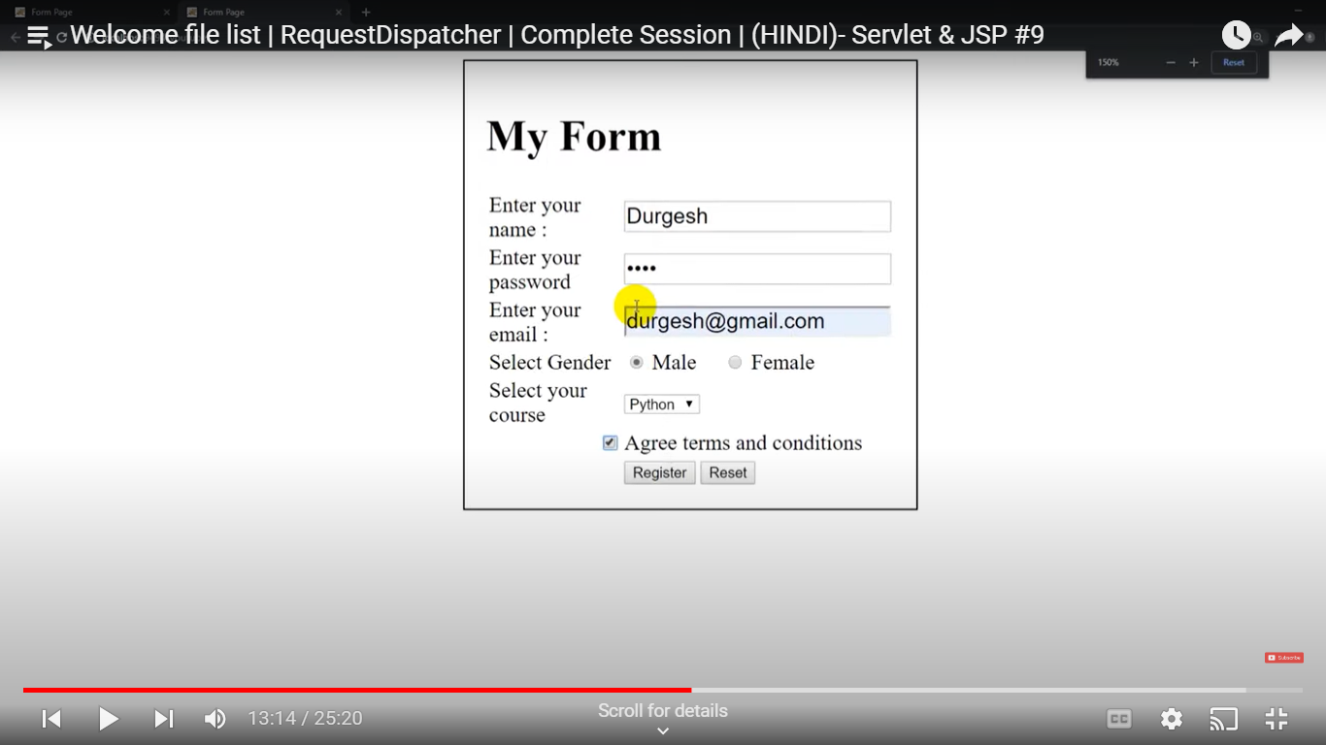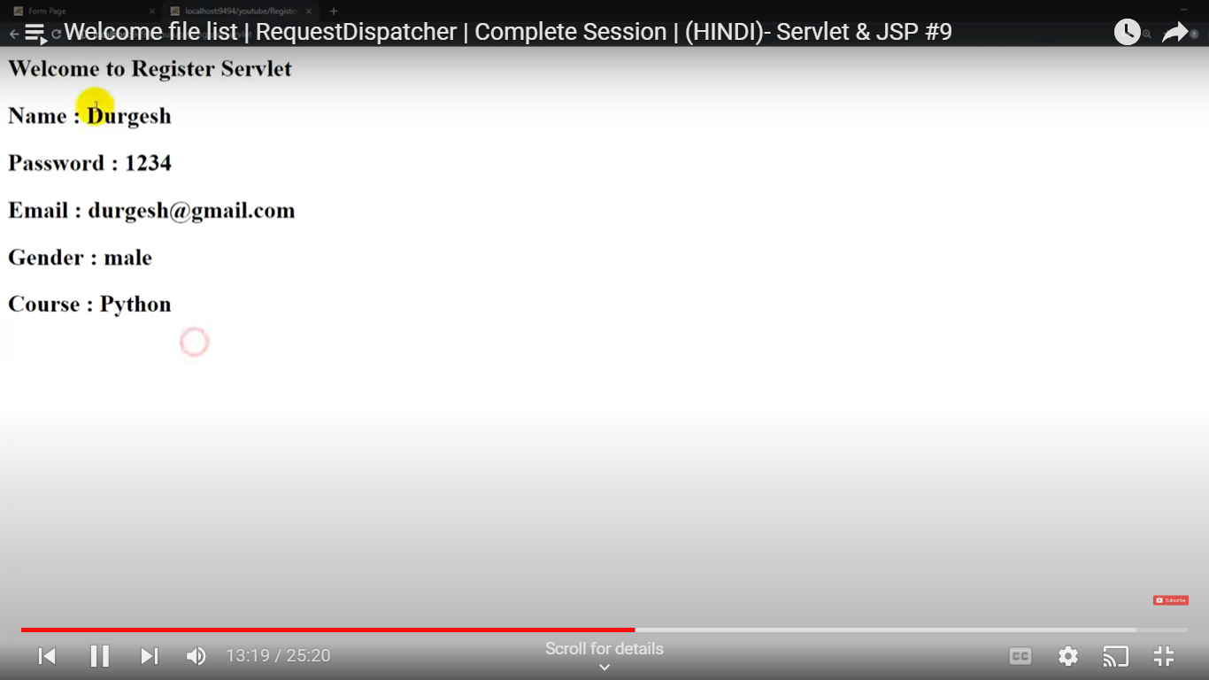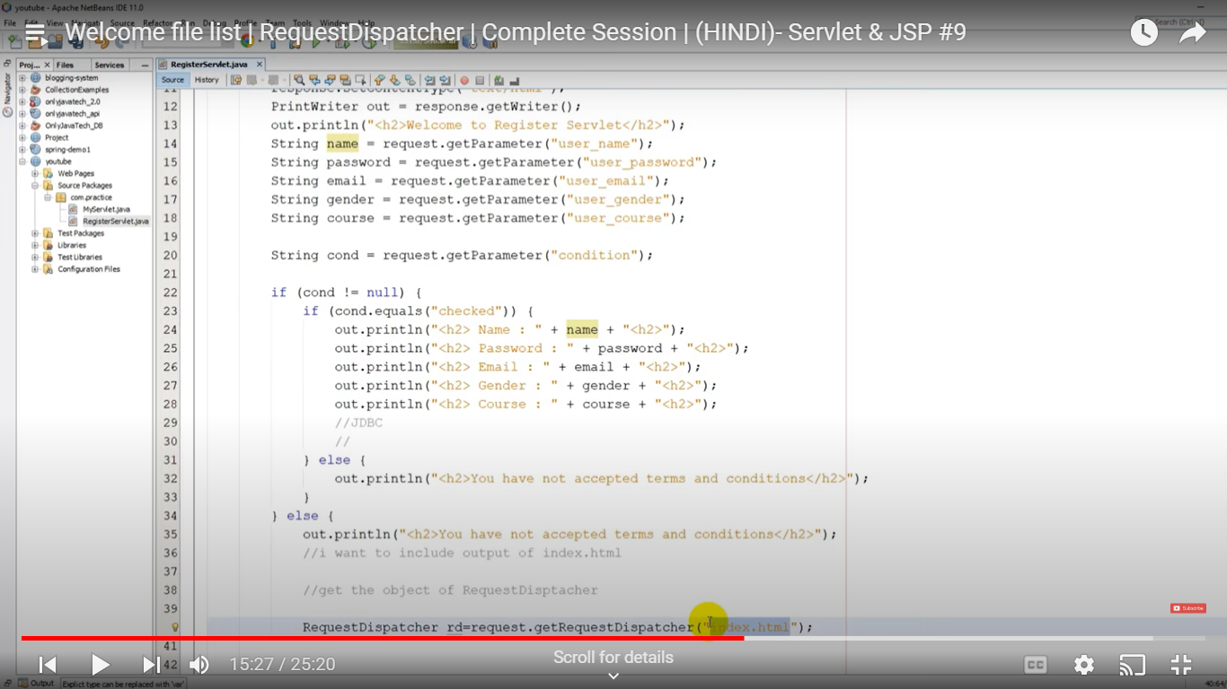

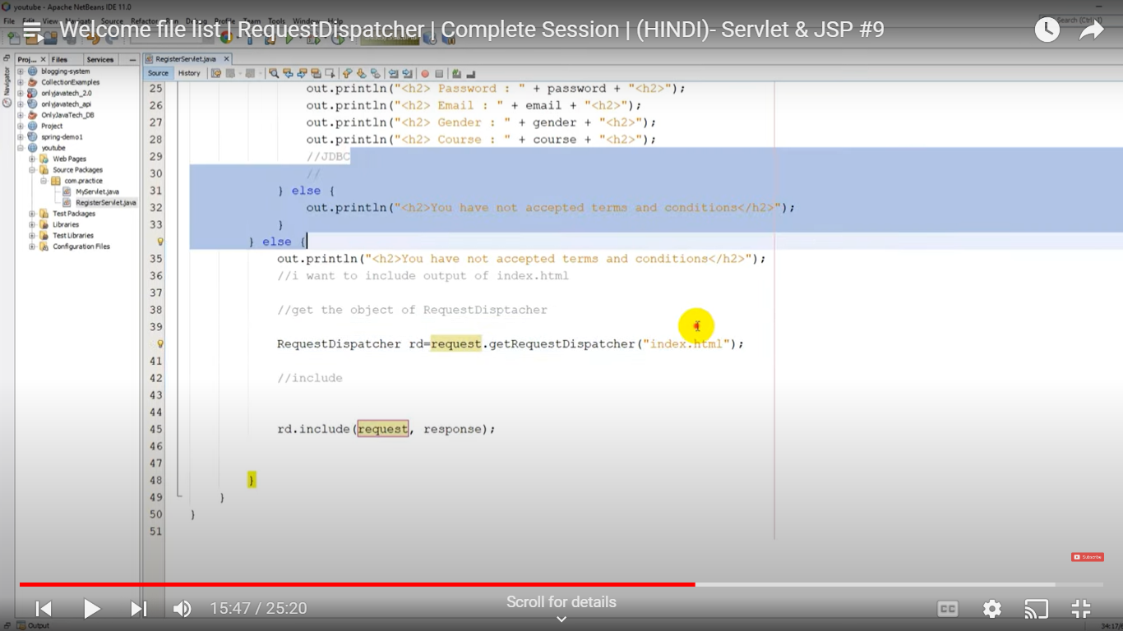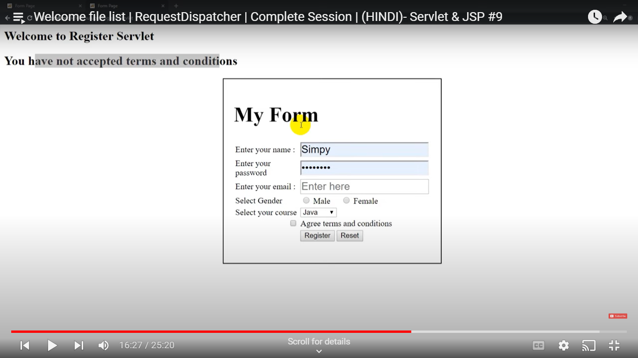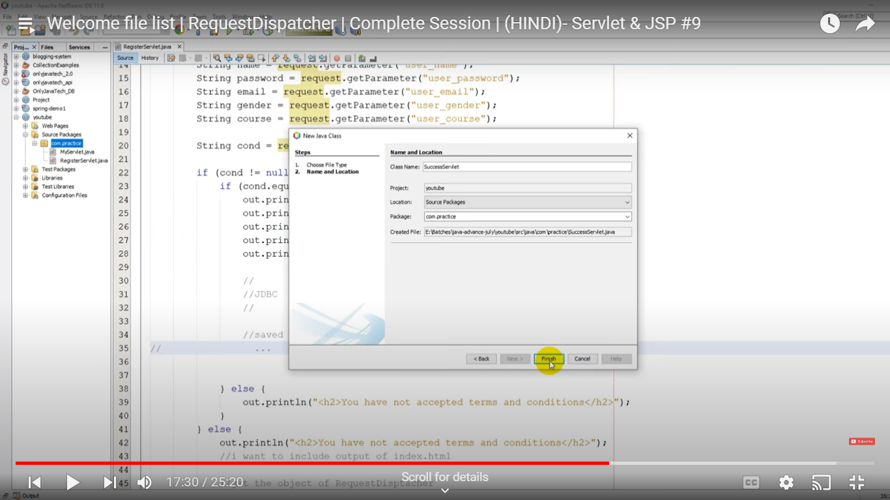

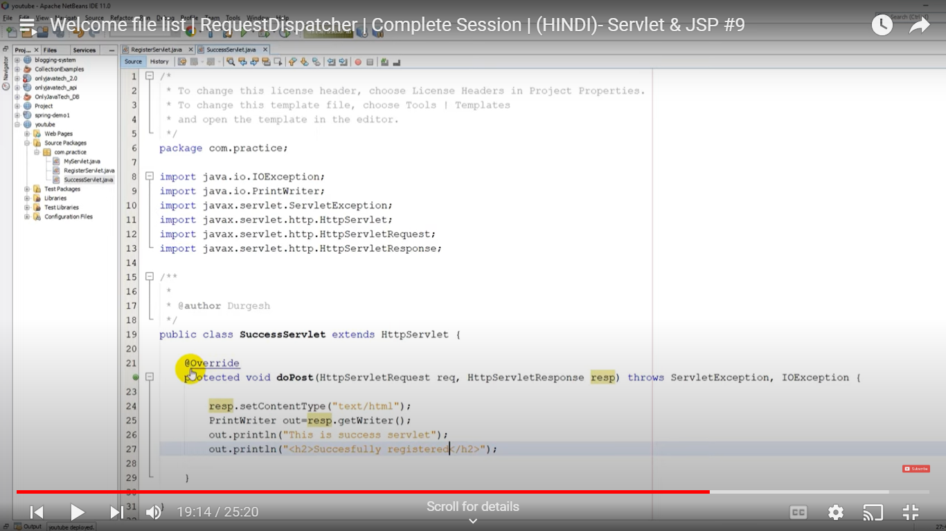

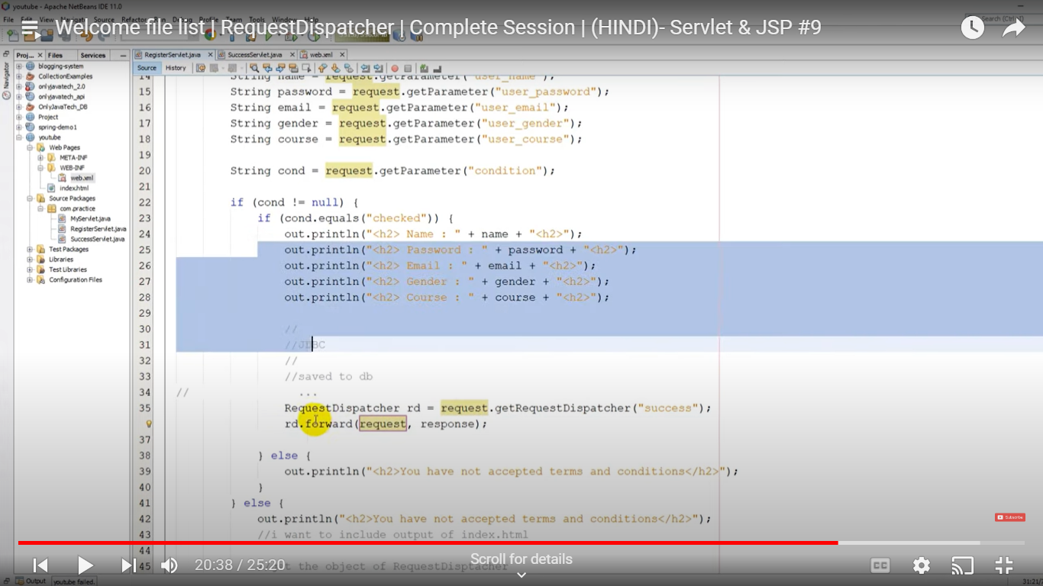

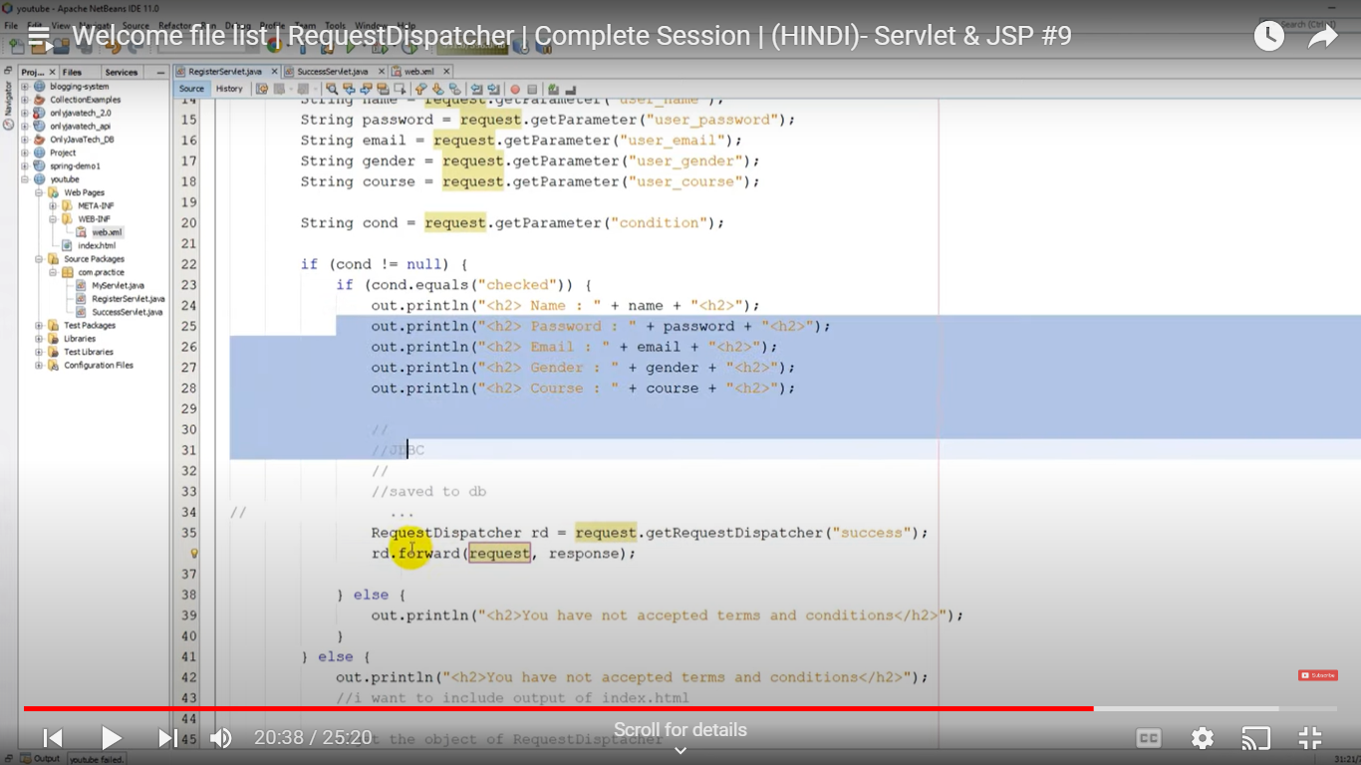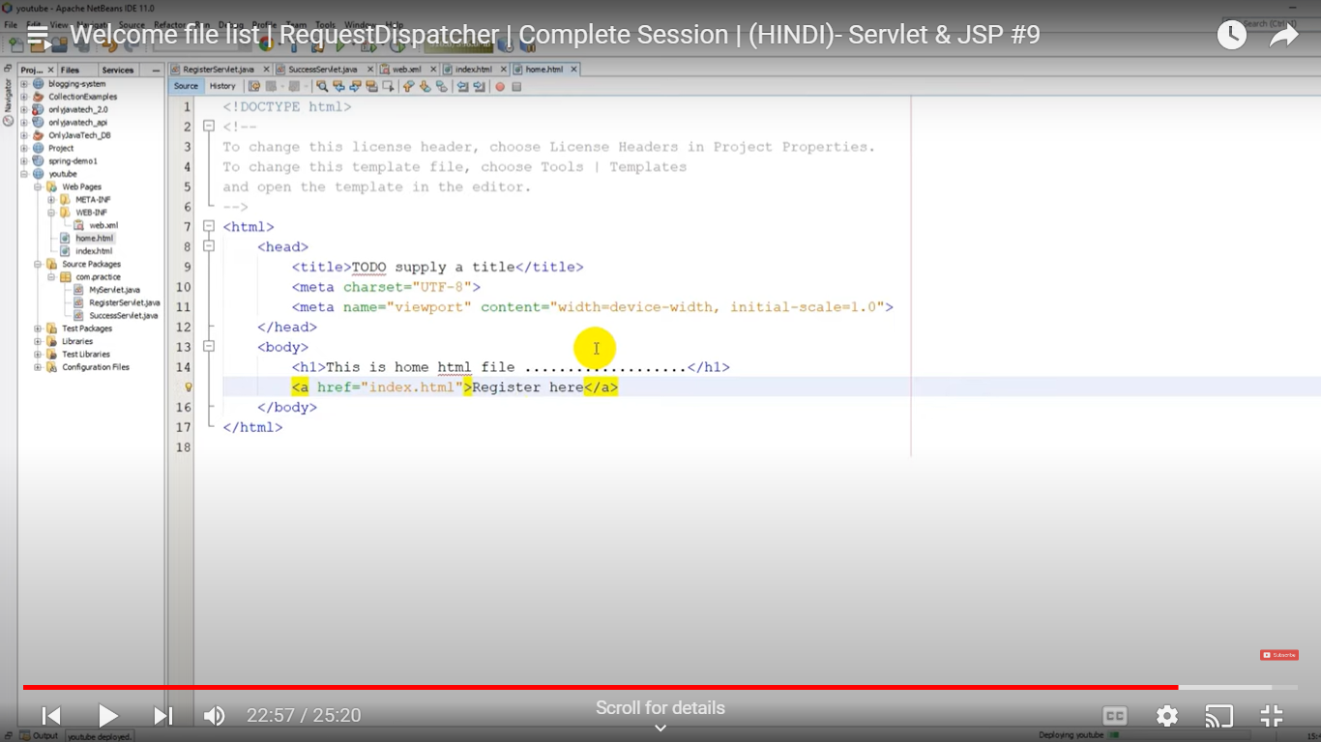

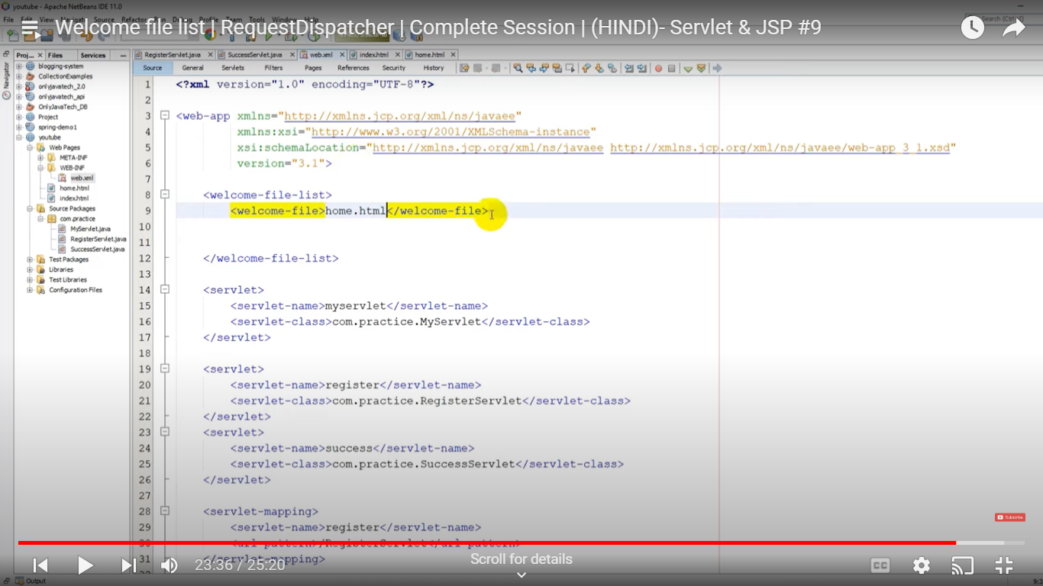

**Next Example:**

**Http Session:**

//first servlet

import java.io.*;  
import javax.servlet.*;  
import javax.servlet.http.*;  
  
  
public class FirstServlet extends HttpServlet {  
  
public void doGet(HttpServletRequest request, HttpServletResponse response){  
 try{  
  
 response.setContentType("text/html");  
 PrintWriter out = response.getWriter();  
   
 String n=request.getParameter("userName");  
 out.print("Welcome "+n);  
   
 HttpSession session=request.getSession();  
 session.setAttribute("uname",n);  
  
 out.print("<a href='servlet2'>visit</a>");  
   
 out.close();  
  
 }catch(Exception e){System.out.println(e);}  
 }  
  
}

**\\\\\\**

// second servlet

import java.io.*;  
import javax.servlet.*;  
import javax.servlet.http.*;  
  
public class SecondServlet extends HttpServlet {  
  
public void doGet(HttpServletRequest request, HttpServletResponse response){  
 try{  
  
 response.setContentType("text/html");  
 PrintWriter out = response.getWriter();  
   
 HttpSession session=request.getSession(false);  
 String n=(String)session.getAttribute("uname");  
 out.print("Hello "+n);  
  
 out.close();  
  
 }catch(Exception e){System.out.println(e);}  
 }  
   
  
}

**.html**

<form action="servlet1">

Name:<input type="text" name="userName"/><br/>

<input type="submit" value="go"/>

</form>

**Example:**

**Configuration Servlet**

import java.io.*;  
import javax.servlet.*;  
import javax.servlet.http.*;  
  
public class DemoServlet extends HttpServlet {  
 public void doGet(HttpServletRequest request, HttpServletResponse response)  
 throws ServletException, IOException {  
  
 response.setContentType("text/html");  
 PrintWriter out = response.getWriter();  
   
 ServletConfig config=getServletConfig();  
 String driver=config.getInitParameter("driver");  
 out.print("Driver is: "+driver);  
   
 out.close();  
 }  
  
}

**HTML Syntax**

<!-- The below is HTML code -->

<body>

<h1>HTML Tags Example</h1>

<h2>Basic Tags</h2>

<!-- Paragraph tag -->

<p>This is a <strong>paragraph</strong> tag. It is used for text content.</p>

<!-- Heading tags -->

<h3>Heading Tags</h3>

<h1>Heading 1 (largest)</h1>

<h2>Heading 2</h2>

<h3>Heading 3</h3>

<h4>Heading 4</h4>

<h5>Heading 5</h5>

<h6>Heading 6 (smallest)</h6>

<!-- List tags -->

<h3>List Tags</h3>

<!-- Unordered List -->

<ul>

<li>Item 1</li>

<li>Item 2</li>

<li>Item 3</li>

</ul>

<!-- Ordered List -->

<ol>

<li>First item</li>

<li>Second item</li>

<li>Third item</li>

</ol>

<!-- Definition List -->

<dl>

<dt>HTML</dt>

<dd>HyperText Markup Language</dd>

<dt>CSS</dt>

<dd>Cascading Style Sheets</dd>

</dl>

<h2>Advanced Tags</h2>

<!-- Links -->

<h3>Links</h3>

<p>Visit our website: <a href="https://www.example.com">Example.com</a></p>

<!-- Images -->

<h3>Images</h3>

<img src="https://via.placeholder.com/150" alt="Placeholder Image">

<!-- Tables -->

<h3>Tables</h3>

<table border="1">

<tr>

<th>Header 1</th>

<th>Header 2</th>

</tr>

<tr>

<td>Row 1, Cell 1</td>

<td>Row 1, Cell 2</td>

</tr>

<tr>

<td>Row 2, Cell 1</td>

<td>Row 2, Cell 2</td>

</tr>

</table>

<!-- Forms -->

<h3>Forms</h3>

<form action="/submit" method="post">

<label for="name">Name:</label>

<input type="text" id="name" name="name" required>

<br>

<label for="email">Email:</label>

<input type="email" id="email" name="email" required>

<br>

<input type="submit" value="Submit">

</form>

<!-- Comments -->

<h3>Comments</h3>

<!-- This is an HTML comment. It won't be displayed in the browser. -->

<!-- Div and Span -->

<h3>Div and Span</h3>

<div class="important-text">This is a div element with class.</div>

<p>This is a <span class="important-text">span element with class.</span></p>

</body>

</html>